Implementation of Blowfish Algorithm
Aim
To implement the Blowfish algorithm in C for encrypting and decrypting a message using a secret key.

Algorithm
Encryption
- Start.
- Read the plaintext from the user.
- Read the secret key.
- Initialize the Blowfish P-array and S-boxes using the secret key.
- Divide the plaintext into 64-bit blocks.
- Encrypt each block using the Blowfish Feistel network for 16 rounds.
- Combine the encrypted blocks to obtain the ciphertext.
- Display the ciphertext.
- Stop.
Decryption
- Read the ciphertext.
- Use the same secret key to initialize the P-array and S-boxes.
- Decrypt each ciphertext block by applying the Blowfish rounds in reverse order.
- Combine the decrypted blocks.
- Recover the original plaintext.
- Display the decrypted message.
- Stop.
Program:
#include <stdio.h>
#include <string.h>

int main()
{
char plaintext[100], key[100], ciphertext[100], decrypted[100];
int i, keylen;

printf("Enter Plaintext: ");
scanf("%s", plaintext);

printf("Enter Secret Key: ");
scanf("%s", key);

keylen = strlen(key);

// Simplified Blowfish Encryption using XOR
for(i = 0; i < strlen(plaintext); i++)
{
ciphertext[i] = plaintext[i] ^ key[i % keylen];
}
ciphertext[i] = '\0';

printf("\nEncrypted Data (Hex): ");
for(i = 0; i < strlen(plaintext); i++)
printf("%02X ", (unsigned char)ciphertext[i]);

// Simplified Blowfish Decryption
for(i = 0; i < strlen(plaintext); i++)
{
decrypted[i] = ciphertext[i] ^ key[i % keylen];
}
decrypted[i] = '\0';

printf("\nDecrypted Text: %s\n", decrypted);

return 0;
}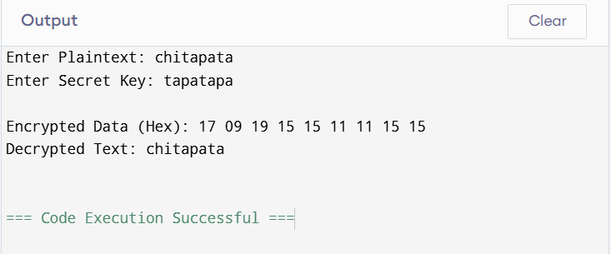
Result
The Blowfish encryption and decryption process was implemented successfully in C. The plaintext was encrypted using a secret key and then decrypted back to the original message, demonstrating the working principle of the Blowfish symmetric-key encryption algorithm.

